Cloud Contacts

Submitted by,

Prakash Jha
……………………………….
Shankar Pandit
………………………………
Sudipto Roy Choudhury
………………………………
Vikrant Rai
………………………………

Nairanjana Chowdhury
Under the guidance of ……………………………….

Submitted for the partial fulfillment for the degree of Bachelor of Technology in Computer Science and Engineering



Techno India
EM 4/1, Salt Lake, Sector – V, Kolkata – 700 091.
ACKNOWLEDGEMENT

We would like to express our sincere gratitude to Miss Nairanjana Chowdhury, of the department of Computer Science and Engineering, whose role as project guide was invaluable to the project. We are extremely thankful for the keen interest she took in advising us, for the books and reference materials provided for the moral support extended to us.

Last but not the least we convey our gratitude to all the teachers for providing us the technical skill that will always remain as our asset and to all non-teaching staff for the gracious hospitality they offered us.

Place: Techno India, Salt Lake

Date:

………………………………

………………………………

………………………………

………………………………

Department of Computer Science and Engineering
Techno India, Salt Lake
Kolkata – 700 091
West Bengal, India.

Approval

This is to certify that the project report entitled “ Cloud Contacts” prepared under my supervision by …(Name and Roll Number)…., be accepted in partial fulfillment for the degree of Bachelor of Technology in ……………………………………….

It is to be understood that by this approval, the undersigned does not necessarily endorse or approve any statement made, opinion expressed or conclusion drawn thereof, but approves the report only for the purpose for which it has been submitted.

……………………………………….. … ………………………………………
Name & Designation of Internal Guide Name & Designation of the HOD

Contents: Page Numbers

1. Introduction

2. Problem Definition

3. Related Study

4. SRS (Software Requirement Specification)

5. Planning [Scheduling using any related software (like MS Project), Cost Analysis (use related software), Software Life Cycle Model (which one you used), Test Plan (Black box and White Box Testing will be included in this part.]

6. Design [Any self generated/modified algorithms used and pictorial view of your design using any preferred tool.]

7. References / Bibliography

List of Tables: Page Numbers

Table 1.1 (Captions should be in bold and centrally aligned)

- Sample Table
Table Head | Table Column Head
Table Head | Table column subhead | Subhead | Subhead
copy | More table copyª
a. Sample of a Table footnote. (Table footnote)

List of Figures: Page Numbers

Fig. 2.1 (Captions should be in bold and centrally aligned)
Fig. 4.5
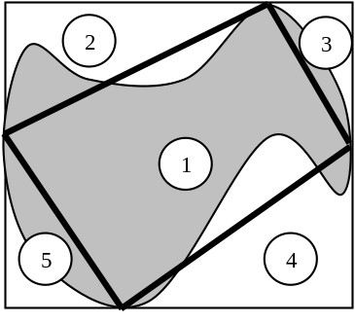

Figure 1.1: Sample figure

Figure captions should be below the figures; table heads should appear above the tables. Insert figures and tables after they are cited in the text.

Use a text box to insert a graphic (which is ideally a 300 dpi TIFF or EPS file, with all fonts embedded) because, in an MSW document, this method is somewhat more stable than directly inserting a picture.

To have non-visible rules on your frame, use the MSWord “Format” pull-down menu, select Text Box > Colors and Lines to choose No Fill and No Line.

Some general observations for a project report:

- Font Style=”Times New Roman”, Font Size=”12” and Alignment=”Justified” should be used for the project documentation.
- Page numbers should be included in the documentation, and the numbering should be given at the bottom of each page, aligning them centrally, excepting the first 3 pages.
- 1 spiral bound copy of the project report will have to be submitted at the time of the examination.

